Blueprint basis for pixel physics

Each material will have it's own unique collider to determine how it spreads on landscape and how it's affected by physics.

Sprites for the objects will be larger than the collider to give it a fuller look.

Rocks will have a square collider so they don't roll much once hitting ground.
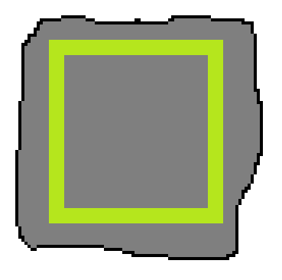
Sand can be slightly more rounded to allow it to “flow better and spread as opposed to stack

Same concept with water except less likely to stack by having a round collider
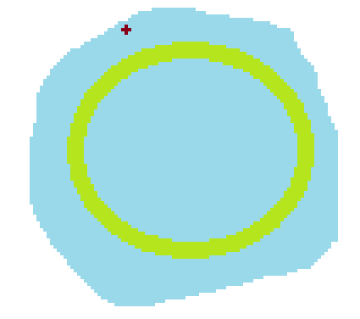
There will be background material. If a certain material is anchored to or touching the collider of a pixel that is anchored to the background, then physics on it will be disabled. This is how trees will appear to stand and buildings can be structured.
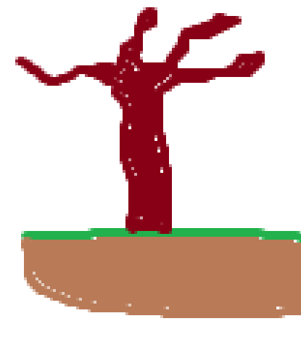
If the connection between the anchored pixels and the suspended pixels is cut, then they will resume physics movement and fall to the ground. This will fell trees and turn structures into piles of rubble.
